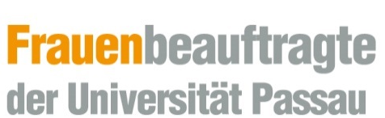

Application for a scholarship under the Realisation of Equal Opportunities for Women in Research and Teaching (FFL) programme

Application for a scholarship for:

☐ doctoral research
☐ postdoctoral research
☐ habilitation research

Requested funding term:
to
From (date)

Career goal:

- Applicant’s details

  - Family name, given name, academic title:

1.2 Date and place of birth:

1.3 Nationality:

  - Marital status:

  - Children (if any; please indicate their names and dates of birth):

1.6 Address:

E-mail:

Phone:
2) Your research project

2.1 Title of thesis or other project

2.2 Supervisor; reviewer

3) Are you receiving a scholarship from another organisation?

☐ no
☐ yes

Name of the scholarship:

Duration of the scholarship:

Type of scholarship:

4) Are you employed at the University of Passau and does part of the scholarship period fall within your employment dates?

☐ no
☐ yes

Type of employment:

Duration of the contract:

Working hours:

5) Will you be gainfully employed in a secondary occupation during the scholarship period?

☐ no
☐ yes

Type of employment:

Working hours per month:

Employment dates (to/from):

Supporting documents

- Application form
- Chronological CV
- Copies of your degree certificates and transcripts and secondary-school leaving certificate and report card(s)
- Two signed evaluation reports from university professors, one of whom must be from outside the University of Passau, and – for habilitations according to the new rules – one from a subject mentor (Fachmentorat)
- A description of the envisaged research project conforming to academic conventions (topic, concept and objective, work plan, research methods used, preliminary work)
- Statement on how the scholarship will be part of the applicant’s overall career plan
- If applicable, a copy of each of your children’s birth certificates
- Information on your publications and lectures to date

Please note:
- The signed reports must be sent to the Women’s Office (Frauenbüro) by post or internal mail. These may be sent in advance by e-mail, but even so, still need to be sent in hardcopy.
- All documents can be submitted in English.

Mentor Applicant

............................................................ ............................................................
Date, mentor’s signature Date, applicant’s signature

